|  |  |  |
| --- | --- | --- |
|  |  |  |
|  |  |  |
|  |  |  |
| Rent à Porter  Rental Dresses Website  Senior Project  **By Mohammad Ali Jaber**  Submitted to the School of Arts & Science of the  Lebanese International University  In part of fulfilment of the requirements for the degree of  **BACHERLOR OF SCIENCE IN**  **COMPUTER SCIENCE AND INFORMATION TECHNOLOGY**  Supervised By: Dr Nehme Rmeity |
|  | **Spring 2023-2024** |  |
|  |  |  |
|  |  |  |

# Dedication

I shall first dedicate my effort to our all-powerful God, who bestowed upon me the wisdom and fortitude necessary for daily existence.

To my cherished parents and friends: thank you for always being there for me as I work and study, and for assisting me in realising my potential.

Finally, I would like to thank my esteemed professor Nehme Rmeity for patiently guiding me towards my goal and helping me get beyond every challenge I encountered throughout the course of my project.

# Acknowledgment

I have dedicated a great deal of time and energy to my "Rent a Porter" project.

Nevertheless, without the generous and unique assistance of some people and organisations, it would not have been finished on schedule or looked the way I had envisioned. I want to sincerely thank every one of them.

I have a great deal of gratitude to my professor Nehme Rmeity for all of his help and support throughout my thesis, as well as for his ongoing supervision.

I would also like to express my gratitude to my parents and friends for their support, which enabled me to complete this project on schedule and flawlessly.

# Abstract

I am developing an online rental system that will enable clients to rent designer dresses from or rent their own designer dresses online via the internet on Rent a Porter website. For both lenders and customers, the online system offers a plethora of functions. To elaborate, my clients value the ability to browse dresses, view dress specifics (designer, size, colour, and price), and contact administrators, when necessary, over-all other capabilities. Furthermore, the dresses can only be added to a shopping cart by registered users. Lenders, however, have the ability to add, remove dresses.

Every element that is offered on my website is thoroughly explained throughout my proposal. In summary, my online rentals system's goal is to give clients a unique service that enables them to conveniently rent whenever and wherever they choose.

# Table of contents

Dedication 2

Acknowledgment 2

Abstract 3

Table of contents 4

Chapter 1 4

1. Introduction: 4

2. Objective: 4

3. Scope: 4

4. Technology Constraints: 4

5. Problem: 4

6. Solution: 4

Chapter 2 4

1. Functional and Conceptual Study 4

1.1. Functional Requirements: 4

1.2. Nonfunctional Requirements: 4

2. UML Use Case Diagram & Scenario 4

2.1. Use Case Diagram 4

2.2. Use Case scenarios 4

Chapter 3 4

1. System Design 4

1.1. ER-Diagram: 4

Chapter 4 4

1. Conclusion 4

2. Future Work 4

# Chapter 1

This chapter will outline the issue I discovered and how my project contributes to its resolution. It will also discuss the technological limitations I faced and my goal, all of which will be thoroughly explained.

## Introduction:

The fashion industry is always changing in today's fast-paced world, and designer clothes are frequently very expensive. For fashionistas who want to wear the newest styles without going over budget, this is a problem. The advent of internet platforms for renting dresses presents a convincing resolution to this issue. The idea and advantages of a service that lets consumers rent designer garments for a small portion of the retail price are covered in my report. This creative strategy gives people the chance to become lenders and monetise their wardrobe in addition to making high-end clothes more widely available. This paper attempts to show how the rental dress model is changing the fashion scene and satisfying the expectations of contemporary customers by examining the financial and practical benefits of renting over buying.

## Objective:

The main objective of my platform (website) for the "Rent a Porter" project is to enable people to wear designer dresses without worrying about the high costs associated with purchasing them. By offering a rental service, users can enjoy the luxury of designer fashion at a fraction of the price. Additionally, the platform seeks to eliminate the challenges of traditional shopping, such as limited space, time, and location, while providing an opportunity for individuals to monetize their wardrobe by signing up as lenders. This approach aims to enhance customer satisfaction and accessibility to high-end fashion.

## Scope:

This system describes the modelling and requirement analysis of the rental dresses website. It aims to eliminate the challenges customers face in traditional shopping stores. This system can be implemented for any local boutique or multinational branded shops. The platform offers the convenience of accepting orders 24/7 and includes a home delivery service, enhancing customer satisfaction. By providing an online portal where customers can easily rent designer dresses from anywhere, shops can retain their customer base and compete effectively with the trending online rental platforms.

## Technology Constraints:

**Software needed:** Visual Studio Code, Xampp, Chrome Web browser

**Languages:** php, javascript, html, css, MySQL

**Frameworks and Libraries:** bootstrap, W3Schools

**Hardware:** laptop

## Problem:

In traditional shopping, people face many problems:

* They must drive to stores to buy or rent what they want, so they have to pay transportation expenses.
* Most of the stores are open only during the daytime, but many people are unable to go shopping due to their job or other reasons.
* Products available in traditional stores generally tend to be very expensive.
* Crowded stores never create a pleasant experience for customers.

## Solution:

Creating an online rental system that will help in:

* Advertising our products online
* Allowing customers to search easily for their needs
* Helping customers in saving money and time
* Offering more choices for customers
* Providing unique customer experience

# Chapter 2

This chapter describes both functional and non-functional requirements for the project. In addition, it shows the UML use cases and scenarios with all related details.

## Functional and Conceptual Study

## Functional Requirements:

* **Sign Up:** Every person can view the store but only registered people who have an account can add items to card, favourites and place orders.
* **Item Selection:** Customer must be able to view his/her orders history and should be able to validate and confirm their invoice.
* **Browsing Through Dresses:** The customer will be given a web interface which allows easy browsing through the different dresses. Basically, the items in the shop are well organized and well-presented so that a user can find his enquired item easily.
* **Login:** The system allows customers and lenders to login easily to view their own orders, items using their email and password.
* **Filtering Items:** Users can apply filters to limit their choices when browsing dresses.
* **Category selection:** Customers are allowed to choose which occasion they want to rent a dress for.
* **Favourites Page:** Customers are allowed to add items to their favourites page and to view this page as well.

## Nonfunctional Requirements:

* **Security:**
  + Login: Any users who make use of the system needs to hold a login email and password.
  + Lenders Rights: The lenders can view as well as delete any item they upload in the online rental system.
* **Performance:**
  + Fast Response Time for User Login (The average response time for user login after entering email and password should be no more than 3 secs and the maximum response time should be 10 seconds)
  + Fast Average Time for Rendering a Page (After clicking on any link the result should be rendered within no more than 1 second in average and it should not take more than 10 seconds in maximum)
  + Minimum number of concurrent users (The website should be able to address at least 1000 users concurrently)
* **Maintainability:** 
  + Errors: The system will track every mistake.
* **Reliability:** 
  + Availability: The system is available all the time (24/7 available)

## UML Use Case Diagram & Scenario

## Use Case Diagram

User actor uses our website to rent dresses online. Top level use cases are **browse, add to cart, add to favourites, rent a dress, buy a gift card**. Browse use case can be used by user as top-level use case if the user only wants to find and see some dresses. **Login** use case allows a user to login to his page and view his/her orders.

**Sign up** use case is included in login.

For the Lender actor there are several use cases which will be discussed below with details.

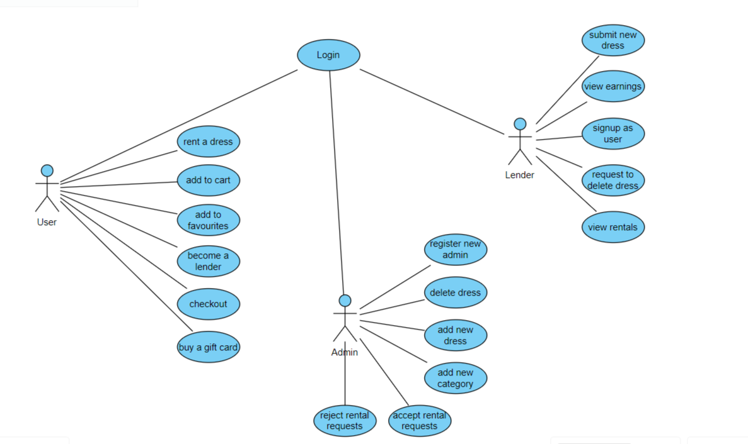*Figure 1 – Use Case Diagram*

## Use Case scenarios

In this part we will be explaining some of the mentioned use cases in details, regarding primary actors, main flow, and the alternative one. In addition to a short description for each use case making all points clear.

* Browse Dresses Use Case:

|  |
| --- |
| Use case name: Browse Dresses |
| Actor(s): User |
| Brief Description: Allow users to view the available dresses on the website. |
| Basic Flow:   * User navigates to the "Browse Dresses" section of the website. * System displays a list of available dresses. * User can filter dresses by size, colour, and occasion. |
| Alternative Flow: None |
| Pre-conditions: None |
| Post-conditions: User views the list of available dresses. |

* View Dress Detail Use Case:

|  |
| --- |
| Use case name: View Dress Details |
| Actor(s): User |
| Brief Description: Allow users to view detailed information about a specific dress. |
| Basic Flow:   * User selects a dress from the list of available dresses. * System displays detailed information about the selected dress (e.g., description, size, rental price). |
| Alternative Flow: None |
| Pre-conditions: User is browsing dresses on the website. |
| Post-conditions: User views detailed information about the selected dress. |

* Add Dress to Cart Use Case:

|  |
| --- |
| Use case name: Add Dress to Cart |
| Actor(s): User |
| Brief Description: Allow users to add dresses to their shopping cart for rental. |
| Basic Flow:   * System adds the dress to the user's cart. * User selects the option to add the dress to their shopping cart. |
| Alternative Flow: None |
| Pre-conditions:   * Login * User is viewing dress details. |
| Post-conditions: Dress is added to the user's shopping cart. |

* Rent Dresses Use Case:

|  |
| --- |
| Use case name: Rent Dresses |
| Actor(s): User |
| Brief Description: Allow users to proceed to rent the dresses in their shopping cart. |
| Basic Flow:   * User navigates to the "Checkout" section of the website. * System prompts the user to provide rental details (e.g., rental period). * User confirms the rental and proceeds to payment. |
| Alternative Flow: None |
| Pre-conditions: User has dresses added to their shopping cart. |
| Post-conditions: User successfully rents the selected dresses. |

* View Earnings Use Case:

|  |
| --- |
| Use case name: View Earnings |
| Actor(s): Lender |
| Brief Description: Allow lenders to view their earnings and payment transactions from dress rentals. |
| Basic Flow:   * Lender navigates to the "Earnings" section of their account dashboard. * System displays a summary of earnings from dress rentals and payment transaction history. |
| Alternative Flow: None |
| Pre-conditions: Lender is logged in to their account and has completed rental transactions. |
| Post-conditions: Lender successfully views their earnings and payment transactions. |

* List Dresses for Rent Use Case:

|  |
| --- |
| Use case name: List Dresses for Rent |
| Actor(s): Admin |
| Brief Description: List their dresses for rent on the website. |
| Basic Flow:   * Admins navigates to the "Add Dresses" section of their account dashboard. * System displays a form for the lender to input dress details (e.g., name, description, size, colour, rental price, availability). * Lender fills out the form with accurate dress information. * System validates the input data and adds the dress listing to the website's database. |
| Alternative Flow: None |
| Pre-conditions:   * Login as admin * Dresses can be from a lender or local from admin |
| Post-conditions: Dress is successfully listed for rent on the website. |

# Chapter 3

This chapter describes the system design, including the data base of our project, the related tables and the relations between them.

## System Design

## ER-Diagram:

This ER (Entity Relationship) Diagram represents the model of online rental system. It shows all the instruments of database tables and the relations between them. The main entities of the online rental system are dresses, rentals, cart_item, categories, favourites, users, lenders.

Online shopping system entities and their attributes:

* Dresses:
* Users:
* User_address:
* Lenders:
* Designers:
* Categories:
* Favourites:
* Cart:
* Cart_item:
* Rentals:
* Gift_cards:

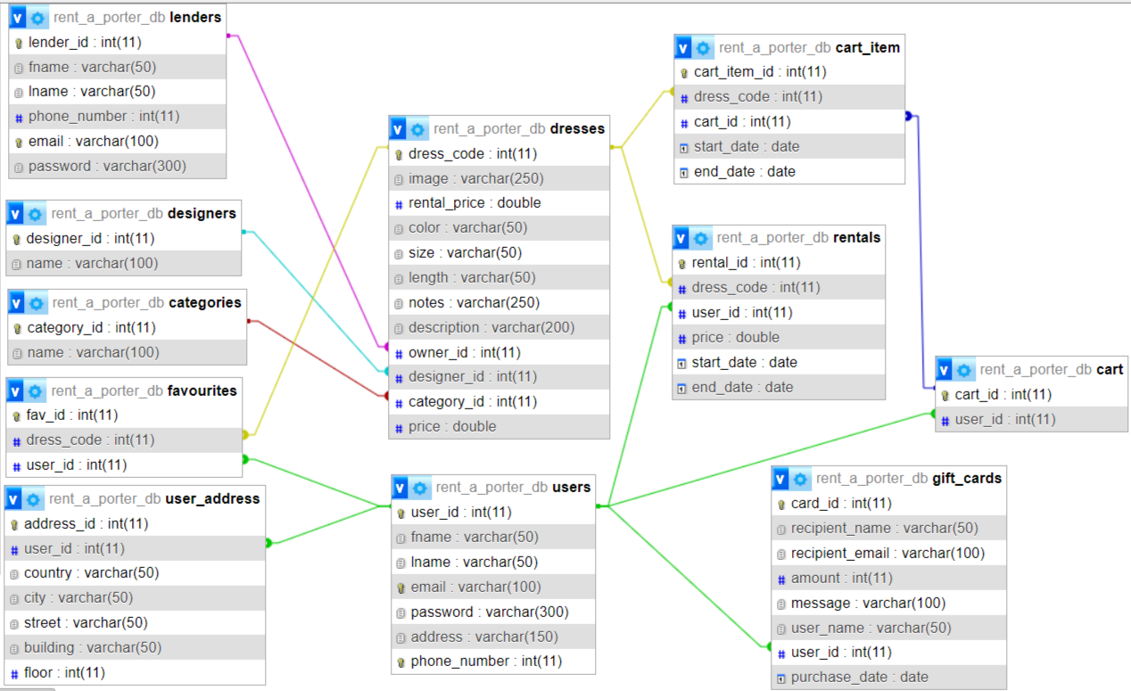*Figure 2 – Relational Diagram*

# Chapter 4

## Conclusion

Developing and implementing an online dress rental system was my goal. This website helps any fashion enthusiast stay up to date with trends and technology, as research has shown that most customers these days prefer the convenience of renting online rather than purchasing or renting in physical stores. Additionally, the platform provides a valuable opportunity for individuals to become lenders, allowing them to rent out their designer dresses and earn extra income. This dual functionality not only broadens the range of available dresses but also fosters a community of users who both rent and lend, enhancing the overall user experience.

## Future Work

Currently, our website operates with cash on delivery for rentals within our nation. However, we plan to add more features to enhance the user experience. These future enhancements include integrating additional payment options, expanding the range of categories and designer brands, and offering a wider variety of dress sizes. Additionally, we aim to develop a mobile app to provide users with greater accessibility and convenience. We also plan to integrate AI for personalized recommendations and efficient inventory management. Furthermore, we envision expanding our services internationally to cater to a global audience. If time and resources allow, these improvements will help make our platform a unique and highly efficient solution for renting designer dresses.